**PROJECT REPORT**

**Title- Visualization tool for Electric Vehicle Charge and Range Analysis**

**1. INTRODUCTION:**

1.1 Overview:

A vehicle that can work by an electric motor that draw electricity from a battery and is capable of being charged from an external source and have an electric motor instead of an combustion engine. The Electric Vehicle has been receiving significantly more attention in recent years. As a result, such a vehicle is being considered as a possible replacement for current-generation vehicles in order to address challenges such as rising pollution, global warming, diminishing natural resources, and so on.

In this project we have collected various data regarding electric vehicles like the description of an electric vehicle, list of charging stations for electric vehicle, cheapest electric car data etc. And we have performed SQL operations then connected the database to Tableau. This process helps to make the data easily understandable and ready for creating visualization to gain insight into the performance and efficiency. By this data we have performed visualization like finding the charging station for electric vehicles, efficient brands, top speed, prices etc. and we have represented in a form of various charts. We have created a dashboard and story on the basis of visualizations that we have made.

1.2 Purpose:

From this project we are able to know and understand about electric vehicles about their uses and also their demerits. How much faster they have developed in these recent years in India. By working on this project we got an idea about analysing various data given about the electric vehicle and know that which brand is best, their price, body style etc. From them creating dashboard and story. We were also able to know about the operations of the electric vehicles like their charging, efficieny etc.

**2. Problem definition and Design Thinking:**

2.1 Empathy Map:

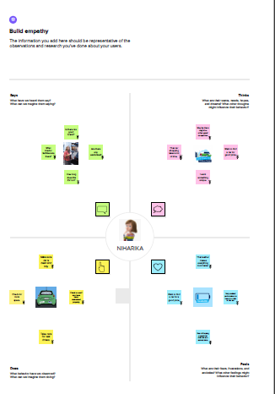

2.2 Ideation and Brainstroming Map:

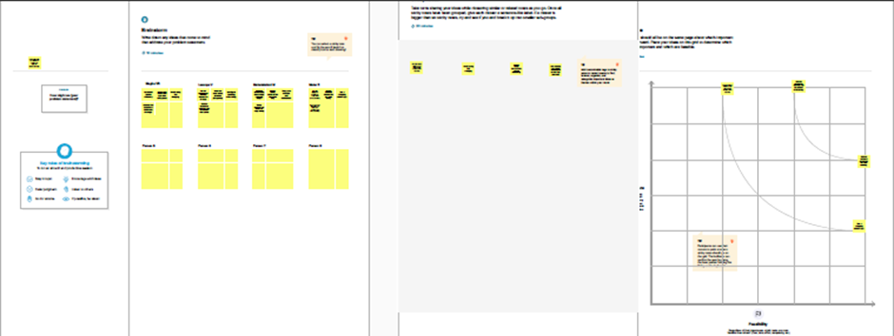

**3. Result:**

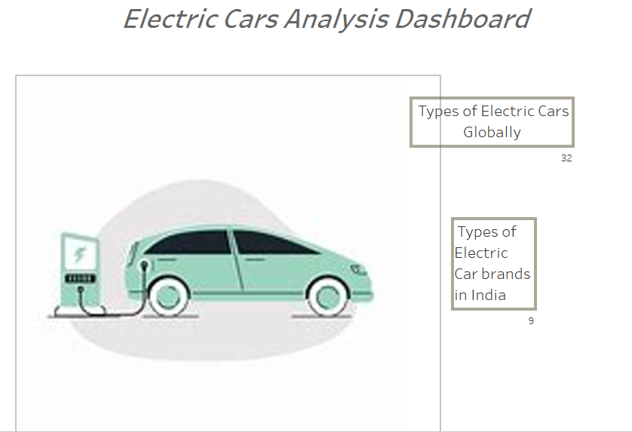

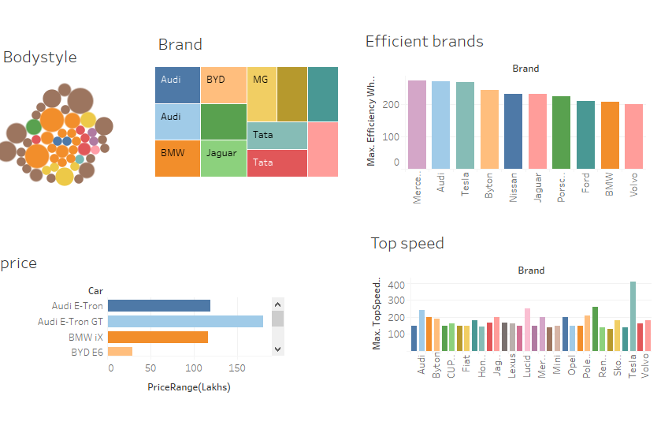

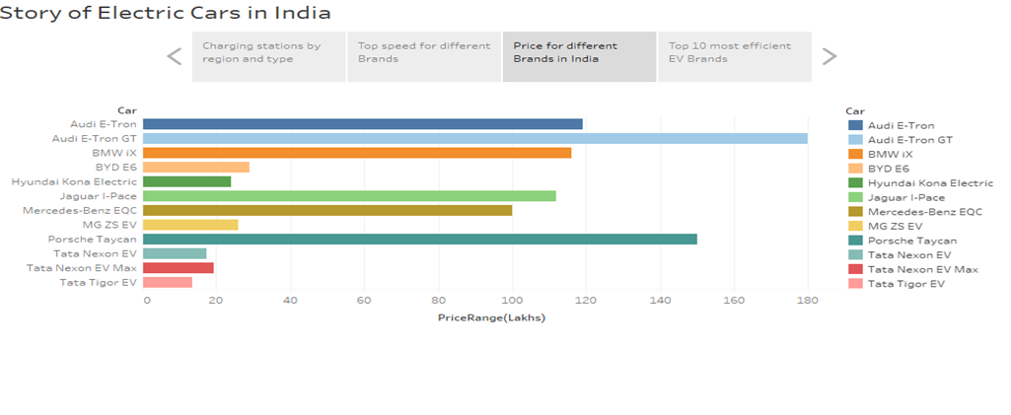

**4. Advantages and Disadvantages:**

ADVANTAGES:

* No fuel required .
* Environmental friendly as they do not emit pollutants.
* Lower maintenance
* Better performance
* Low noise pollution
* More convenient

DISADVANTAGES:

* Higher Purchase Cost
* Low Speed and Range
* Low price on Selling
* The inconvenience of service stations
* Low energy
* Battery Expenses
* Charging issues
* Fewer Users

**5. Applications:**

The running cost of an electric vehicle is much lower than an equivalent petrol or diesel vehicle. Electric vehicles use electricity to charge their batteries instead of using fossil fuels like petrol or diesel. Electric vehicles are more efficient, and that combined with the electricity cost means that charging an electric vehicle is cheaper than filling petrol or diesel for your travel requirements. Using renewable energy sources can make the use of electric vehicles more eco-friendly. The electricity cost can be reduced further if charging is done with the help of renewable energy sources installed at home, such as solar panels. Driving an electric vehicle can help you reduce your carbon footprint because there will be zero tailpipe emissions. You can reduce the environmental impact of charging your vehicle further by choosing renewable energy options for home electricity. Electric vehicles don’t have gears and are very convenient to drive. There are no complicated controls, just accelerate, brake, and steer. When you want to charge your vehicle, just plug it in to a home or public charger. Electric vehicles are also quiet, so they reduce noise pollution that traditional vehicles contribute too. Imagine being at a busy fuel station during peak hours, and you are getting late to reach your workplace. These problems can easily be overcome with an electric vehicle. Simply plug your vehicle in at your home charger for 4-5 hours before you plan to go. If you are able to get a charger where you park at home, it is very convenient to plan your journeys in advance. What if you forget to plug in your machine someday? Then you can easily take the help of fast chargers or even battery swapping services if you are on a two-wheeler on the road.

**6.Conclusion:**

So in conclusion electric vehicles have both advantages and disadvantages. They are a great way to minimize environmental pollution but also have certain disadvantages. We all know that nothing is perfect or adequate. Thus in this project we were able to know more about electric vehicles and visualize them. This project will be helpful when considering an electric vehicle in the future.

**7. Future Scope:**

A rising variety of all-electric vehicles are currently available, and electric cars are already a common sight on the roads. Those who rely heavily on diesel are seeing sales decline, especially when nations like the U.K. have set a deadline of 2030 to terminate sales in combustion automobiles, and the electric effect is in full swing. Reduced costs and a more comprehensive selection of models are being met by more significant investment and the expansion of charging infrastructure. The Wall Street Journal speculated that many people would switch to an electric vehicle to save money once the total cost of owning an electric vehicle is lower than a comparable gasoline-powered one. Consumer Reports asserted that the price in the U.S. has already crossed that threshold, while Car and Driver says federal tax credits play a significant role.

**\*\*\*\*\*\*\*\*\*\*\*\*\*\*\*\*\*\*\*\*\*\*\*\*\*\*\*\*\*\*\*\*\*\*\*\*\*\*\*\*\*\*\*\*\*\*\*\***